# Final:

* User Analysis Dashboard (UAD)
  + Projected time (educated estimate): 120 hours to complete.
    - Not Included it unit testing time: 26 hours
    - Should there be a change in requirement that change the feature, then regression testing
    - Integration testing (done after unit testing): this feature is dependent on 5 other different features. Estimated time:____
  + Possible complications (risk assessment, risk prevention, risk mitigation):
    - Risk assessments:
      * Integration testing fails because unit testing was not implemented
      * User analysis dashboard displaying incorrect data.
      * User analysis dashboard is viewable across all account in the profile page
      * The UAD does not display anything.
    - Risk prevention:
      * Make sure in the like of the project that all requirement changes will be unit tested as needed!
      * Make sure that the logging feature is storing the correct data for the dashboard or that the correct data is correctly retrieved, or that the calculations on the data are correctly done.
      * Enforce User access control for UAD to be viewable only by admin accounts
      * Make sure the UAD is communicating to the database.
    - Risk mitigation:
      * Allow for logging feature implement easy fix to logging of type of data
      * Understand what is being stored and the database design to retrieve data correctly. (preferably have a UML class or relational schema diagram for reference)
      * Enforcement of User access control should take into account UAD is only for admin.
      * Test database connection.
  + What features User Analysis Dashboard interacts with will go here
    - Dependent on the User garage feature ( since dashboard will be displayed in the admin account)
    - Dependent on login in to view dashboard
    - Dependent on UAC (who has access to view this dashboard.ONLY admin)
    - Dependent on network communication to retrieve/ update tables on refresh.
    - Dependent on UI/UX
    - Dependent on the login feature to make sure all needed data is being stored for later use.
  + Test pass/ fail criteria:
    - All testing should pass 95% of the time.

**_____________________________________________________end**

# USER ANALYSIS DASHBOARD:

For each feature determine:

* + Define a series of phases that must be completed to accomplish the feature.
    - Connect SQL Server to the visual studio 2019. See:<https://ozanecare.com/connect-sql-server-with-visual-studio-2019/> OR<https://docs.microsoft.com/en-us/visualstudio/data-tools/add-new-connections?view=vs-2019> (Time: 5 hours) (Test connection: 1 hours) added in the time to download SQL server and manager )
    - Look within the dotnet NuGet library to find packages that make creating user analysis dashboards easy<https://nugetmusthaves.com/Tag/dashboard> + get approval THEN learn the documentation (Time: 45 hours)
      * For example: <https://www.youtube.com/watch?v=qH011QYM40E> OR
      * SEARCH ‘Stimulsoft’ in<https://www.nuget.org/> and find for .net core in particular
      * <https://www.nuget.org/packages/Stimulsoft.Dashboards.Web.NetCore/>
      * Note you can also do the same in visual studio 2019!
        + Under ‘manage NuGet packages’
        + Click browse, Search ‘Stimulsoft’
        + 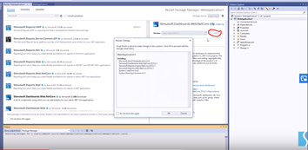
      * Documentation example:<https://www.stimulsoft.com/en/documentation/online/programming-manual/index.html?reports_web_asp_net_core_using_web_viewer_connecting_data.htm>
      * Within the chosen package we must also learn how to connect to the SQL database using a connection string
    - Understand what data needs to be pulled from our SQL database, to be used/ displayed to the dashboard. + learn how to pull and manipulate data (Time: 40 hours) + test to make sure the correct data is being pulled and querying is correct (test time: 10 hours)
    - Querying data from the SQL database (Time: 10hr)
      * Collecting data to calculate
        + For bar chart:Percentage usage of the types of components, average session duration, number of accounts helds.
        + Pie chart: most frequently viewed page (for the number of registered clicked0
        + Testing if data is correctly displayed/ are you querying correctly (Test time: 15 hours)
    - Additional research and learning of c# (estimated time: 10hours)
  + Resources necessary
    - Amount of time it will take for the feature to be completed and start the feature: (5 + (45- 20) + 40 +TEST TIME = 70 + hours?)
    - All research time will be estimated from the total time.
    - Test time = 1 + 10 + 15 = 26

__________________________________________

So in total = 70 + 70* 70% = 70 + 50 = 119 + 26 time estimation to implement user dashboard.

* + Identify any interdependencies.
    - Dependent on the User garage feature ( since dashboard will be displayed in the admin account)
    - Dependent on login in to view dashboard
    - Dependent on UAC (who has access to view this dashboard.ONLY admin)
    - Dependent on network communication to retrieve/ update tables on refresh.
    - Dependent on UI/UX
    - Dependent on the login feature to make sure all needed data is being stored for later use.

# References: (GOING TO DELETE LINKS THAT HAVE TO DO WITH WEB SERVER LOGS, THE BOSS DOESN’T LIKE IT)

# <https://docs.microsoft.com/en-us/sql/?view=sql-server-ver15>

# <https://docs.microsoft.com/en-us/aspnet/core/tutorials/first-mvc-app/working-with-sql?view=aspnetcore-3.1&tabs=visual-studio>

# <https://docs.microsoft.com/en-us/>

# <https://www.mssqltips.com/sqlservertip/6481/install-sql-server-integration-services-in-visual-studio-2019/>

# <https://docs.microsoft.com/en-us/visualstudio/data-tools/add-new-connections?view=vs-2019>

# <https://ozanecare.com/connect-sql-server-with-visual-studio-2019/>

# <https://www.chapelhill.homeip.net/IISView/>

# <https://www.techrepublic.com/article/maximize-iis-logging-to-track-user-activity/>

# <https://docs.devexpress.com/Dashboard/16307/get-started/build-wpf-dashboard-applications/create-a-dashboard-in-visual-studio>

# <https://www.youtube.com/watch?v=qH011QYM40E>

<https://topflightapps.com/ideas/how-to-create-a-dashboard-web-application/>

<https://www.google.com/search?client=firefox-b-1-d&q=nuget+packages+what+is>

<https://docs.microsoft.com/en-us/nuget/quickstart/install-and-use-a-package-in-visual-studio>

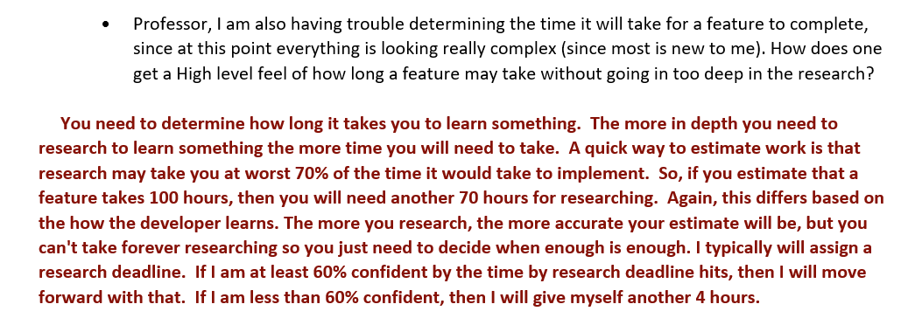

# USER ANALYSIS DASHBOARD: (draft part 2)

Version 2: need to create the user analysis dashboard from scratch as well.

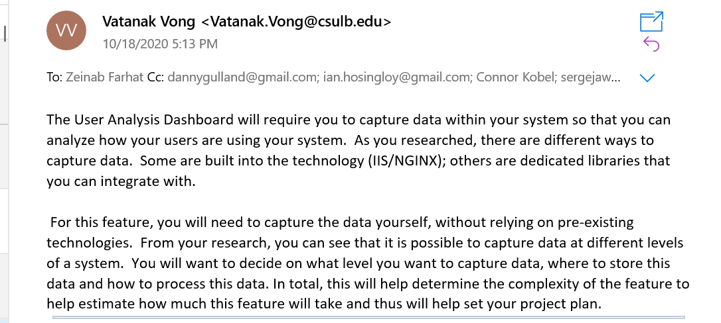

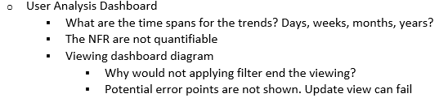

What to do:

Identifying the KPIs you want to track:

* Create bar charts for:
  + Bar 1: Percentage usage of the types of component
  + Bar 2: Average session duration of the user
  + Bar 3: How many accounts does autobuild hold amongst the different account types)
* Create Pie charts for:
  + Most frequently viewed Autobuild view
    - All user interaction (“clicks”) will be logged.
* Create Line graph:
  + Number of registrations took pace date wise (every month)

Layout:

* For each feature determine:
  + Define a series of phases that must be completed to accomplish the feature.
    - Phase 1: create the necessary database tables
      * ‘user activity log table’
    - Phase 2: make the necessary SQL Connection in visual studio
    - Phase 3:
    - Phase 4:
  + Resources necessary
    - Amount of time it will take for the feature to be completed and start the feature
  + Who will be responsible for its execution?
  + Identify any interdependencies.
    - Do certain tasks need to be completed b4 others begin
    - Do other features need to be completed before this feature?
* set milestones for overall projec